**Chapter 6**: **What Do They Look Like?**

**ujuh PTembelajaran:**



Setelah mempelajari Bab 6, siswa diharapkan mampu:

1

2.1

2.2

2.3

3.6

4.9

4.10

Mensyukuri kesempatan dapat mempelajari bahasa Inggris sebagai bahasa pengantar komunikasi International yang diwujudkan dalam semangat belajar.

Menunjukkan perilaku santun dan peduli dalam melaksanakan komunikasi interpersonal dengan guru dan teman.

Menunjukkan perilaku jujur, disiplin, percaya diri, dan bertanggung jawab dalam melaksanakan komunikasi transaksional dengan guru dan teman.

Menunjukkan perilaku tanggung jawab, peduli, kerjasama, dan cinta damai, dalam melaksanakan komunikasi fungsional.

Menganalisis fungsi sosial, struktur teks, dan unsur kebahasaan pada teks ilmiah berbentuk *factual report* tentang binatang.

Menangkap makna dalam teks ilmiah faktual *(factual report)* lisan dan tulis tentang binatang.

Menyusun teks ilmiah faktual *(factual report)* lisan dan tulis tentang binatang dengan memperhatikan fungsi sosial, struktur teks, dan unsur kebahasaan yang benar sesuai konteks.

## WARMER

Do you know animal sounds in English? Guess the sounds of these animals. Use the provided clues to help you. Check your answers with your friends.

1. What does the pig say?
2. What does the horse say?
3. What does the cow say?
4. What does the bee say?
5. What does the little bird say?
6. What does the frog say?
7. What does the cat say?
8. What does the goose say?

**Honk. Honk. Moo.**

**Meow. Meow.**

**Oink. Oink.**

**Neigh-h-h. Buzzz.**

**Tweet. Tweet.**

**Croak. Croak.**

## OBSERVING AND QUESTIONING

### Listening



Task 1: Listen to the text.



Listen to your teacher reading aloud a text about reptiles. Answer the questions briefly.

### Questions

* 1. What does the word reptile mean?
  2. What do reptiles look like?
  3. How do reptiles breathe?
  4. What does cold-blooded mean?
  5. What animals are mentioned as the examples of reptiles?

**Task 2:** Oral description

Listen to your teacher again. Try to answer the questions in Task 1. Your answer will

help you describe reptiles.

### Reading

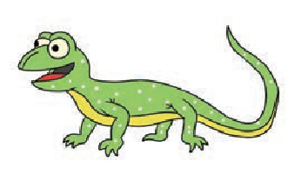**Task 1:** Observe and compare.

#### Observe these two texts about reptiles. In groups, compare them using the questions that follow.

**TExT 1**

What is a reptile?

The word *reptile* means that which crawls. A reptile is an animal that crawls, though some prefer to swim. Reptiles usually have scales on their bodies, like fish, but they breathe through lungs as people do. Reptiles are cold-blooded. This means that the temperature of their blood changes when the air temperature changes. Snakes, turtles, and lizards are all reptiles. So were the ancient dinosaurs. *(Taken from Charlie Brown’s Cyclopedia. Volume 2. 1990.*

*Animals through the Ages: From Alligators to Zebras)*

### TExT 2

uge reHptiles called Dinosaurs lived on earth about 180

million years ago. They flourished and ruled the earth for more than 120,000,000 years. But today we can’t see even a single one of them because all of them died out about 60 million

years ago.

Why such strong and flourishing creatures should suddenly disappear completely is a question that still puzzles the scientists today. The most probable explanation is the climate of the earth changed too much about 60 million years ago for the dinosaurs to continue living.

The huge sized reptiles called Dinosaurs existed in a great variety of sizes. Most were 25 to 30 feet long and weighed from five to ten tons. Some were much smaller, and a few early varieties

were as small as chicken! *(Adapted from All Colour Treasury of Children’s Knowledge by Jayant Gupta. 1993)*

**Questions**

* + 1. Do the texts contain the same type of information?
    2. What linguistic similarities/differences can you identify? (e.g., the use of verbs, the use of adjectives, etc.)
    3. In terms of presentation format and writing, what similarities/differences can you identify from the two texts? Discuss these aspects: number of paragraphs, length of texts, and style in writing.

**Task 2:** Think about it.

Before you read the following text about zebras, talk about these things in small groups.

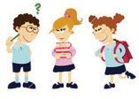

Source: [www.vectorstock.com](http://www.vectorstock.com/)

1a.ve yHou ever seen zebras or pictures of zebras?

1. Have you ever read anything about zebras?
2. What information about zebras did you get from reading?
3. Do you know that the stripes of zebras have some functions?
4. Do you think that zebras are black animals with white stripes, or white animals with black stripes? Why do you think so?

**Task 3:** Read and Skim.

Read and skim each paragraph in the reading text about zebras below. After you skim each paragraph, write the number of the paragraph next to the question it answers.

1. ______________ What do zebras look like?
2. ______________ How many species of zebras are there? 3. _______________ What are zebras?
3. ____________ What are the functions of the stripes of zebras?
4. _______________ Where do zebras live? 6. _______________ What do zebras eat?

ebZras are equids, a family of mammals and members of the horse family, native to Africa. The word “zebra” comes from the Portuguese zevra, which means “wild ass.” One can certainly see how the zebra

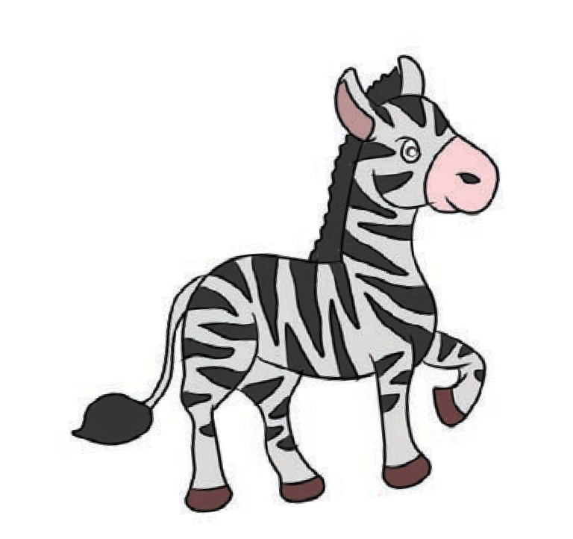

might have been mistaken for the

wild ass at first glance, since the

animals have similar body types.

Zebras are probably most famous for their distinctive striped coats, which make them quite memorable animals.

In addition to being found in parts of Africa, zebras are also held in captivity in zoos and conservation parks in many parts of the world, for people who want to see these animals in person without taking a safari trip. Several attempts have been made to domesticate

the zebra, with some animals being trained as riding or driving animals. However, zebras appear to be too unpredictable and flighty to fully domesticate, despite the best efforts of intrepid riders. Instead, some people breed zebra hybrids, crossing full blooded zebras with horses and other equids to produce more easily trained and handled animals which retain the characteristic zebra stripes.

There are several different species of zebra, but all of them are in the same genus, ***Equus***, which they share with horses. Like other equids, zebras are odd-toed ungulates with muscular bodies which are built for running. Zebras were among the earliest animals to split from the original equids, along with asses, and as a result, they have had an extended period of time to adapt to the unique challenges of the

African landscape.

These animals have very stout, muscular bodies which are designed for immense speed and strength. When threatened, a zebra can choose to run, often choosing a zig-zagging pattern to distract the predator, or they can fight, using powerful jaws and heavy hooves to attack their enemies. Like asses, zebras have tufted tails, and they also have short, upright manes of coarse hair, along with unusually large ears which give these animals a very good sense of hearing.

Zebras are herbivores, eating grass, foliage, and various shrubs. Depending on the species, a zebra may be adapted more for the open plain, or for more heavily wooded and mountainous areas. In all cases, zebras are very social animals, living in large herds which are typically overseen by a single stallion. A zebra's gestation period is 13 months, typically producing a single foal which may join the herd when it reaches adulthood, or strike out on its own to find another group of zebras.

The stripes of the zebra appear to have several functions. For one thing, they distract and confuse predators, especially when

zebras are in a herd formation, because the stripes make it hard to pick out an individual zebra. The stripes also appear to be unique to each animal, allowing zebras to readily identify each other, and they help to camouflage individual zebras, especially in wooded areas, where the play of light and shadow allows the zebra

to blend.

There is some debate as to how to describe the zebra's stripes. They are typically described as white animals with black stripes, but zebras actually have entirely black skin. The most common zebra mutations create animals which are darker, rather than lighter. This proves that the zebra is actually black with white stripes. While this might seem a bit pedantic, it can make a good jumping-off point for ed debates at parties, if one feels so inclined. *(Adapted from* [*http://www.wisegeek.com/what-is-a-zebra.htm)*](http://www.wisegeek.com/what-is-a-zebra.htm))

**COMPREHENSION QUESTIONS**

**Answer the questions briefly.**

1. Where are zebras generally found?
2. What are the most obvious characteristics of zebras?
3. How can people domesticate zebras?
4. What do people do to get more-easily-trained animals?
5. Why can zebras adapt to the African land?
6. How do zebras prevent themselves from predators?
7. Why are zebras called social animals?
8. What are the functions of the stripes?
9. What is being debated? What is the fact? Why do you think so?
10. What does the last sentence mean?

### Vocabulary Builder

**Task 4:** Find the meaning of words.

After reading the text about

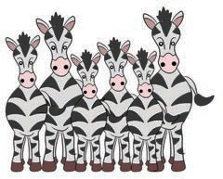

zebras, individually guess the meaning of each word below. Then, check them with your friends. When necessary, consult your dictionary. After that, practice pronouncing the words.

Source: [www.123rf.com](http://www.123rf.com/) Picture 6.2 Zebras

**d i s ti n c ti v e** /dɪ ' stɪŋktɪv /

**c a pti v i t y** /kæp'tɪvɪti /

**d o m e s ti c a te** /də'mestɪkeɪt /

**r e t a in** /rɪ'teɪn /

**d i s tr a ct** /dɪ'strækt /

**her d** /hɜ:rd /

**g e s t at i o n** /dʒe'steɪʃ ə n /

**f oa l** /foʊl /

**m ut a ti on** /mju:'teɪʃ ə n /

**p e d a nt i c** /pɪ'dæntɪk /

### Grammar Review

**Task 5:** Observe the adjectives.

An adjective describes or gives more information about a noun or pronoun. A lot of adjectives are found in the text about zebras.

|  |  |
| --- | --- |
| **Adjectives** | **Nouns** |
| wild | ass |
| distinctive | coats |
| memorable | animals |
| different | species |
| muscular | body |

Can you find in the text some other adjectives and

the nouns that they describe? Write them down here!



**Task 6:** Observe the relating verbs.

Look through the text again. You will find verbs like ***is, was, are, were, have,*** and ***had****.* They are called ***relating verbs****.*

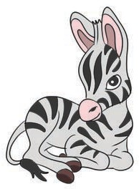Zebras *are* equids, a family of mammals and members of the horse family, native to Africa.

Zebras *were* among the earliest animals to split from the original equids, along with asses.

Underline some other ***relating verbs*** in the text!

# Text Structure

**Task 7:** Observe the text structure.

Source: [www.123rf.com](http://www.123rf.com/) Picture 6.3 A Zebra

he textTabout zebras above is called *a factual report (information report).* A factual report aims at describing general phenomena, natural as well as social.

How are factual reports written? In the model text, the first paragraph of the factual report gives us a **classification** containing some general information about zebras. All the paragraphs that follow the first paragraph contain **some description** about zebras; they contain some detailed features. The paragraphs in the text seem to respond to a series of questions about zebras: the what, why, how, etc.

Read the text again, and then write in the table the appropriate questions about zebras that the paragraphs will answer.

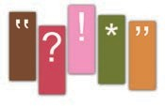

|  |  |
| --- | --- |
| **Parts of the Text** | **Questions to Answer** |
| Paragraph 1 | What are zebras? |
| Paragraph 2 | Where do zebras live? |
| Paragraph 3 |  |
| Paragraph 4 |  |
| Paragraph 5 |  |
| Paragraph 6 |  |
| Paragraph 7 |  |



What is the last paragraph about? How relevant is this paragraph to the overall text? Discuss with

your friends.

**Task 8:** Create subheadings.

n writinIg a factual report, you can use questions to become

the subheadings of the paragraphs. The subheadings become the guides in developing the paragraphs. However, the subheadings do not have to be in the form of questions. You may use words of nouns, like the following examples.

|  |  |  |
| --- | --- | --- |
| Text Structure | Questions as  Subheading | Noun Words |
| Classification | What are zebras? | General Information |
| Description | Where do zebras live? | Habitat |
|  | How many species of zebras are there? |  |
|  | What do zebras look like? |  |
|  | What do zebras eat? |  |
|  | What are the functions of the stripes? |  |
|  | What is debatable? |  |

# COLLECTING INFORMATION

**Task 1:** Find a factual report text.



In groups, find a factual report

text about animals. You can go to the library or search in the Internet. Use the following questions to help you select the text.

* 1. What is the animal?
  2. What does the animal look like?
  3. What does the animal eat?
  4. Where does the animal live?
  5. What other information about the animal is found in the text?

Present your text neatly and attractively so that the other groups want to read it. Take turn sharing the information you have with the class.

**Task 2:** Find the adjectives.

Look through your text. Write down the adjectives and the nouns that they describe in the table below.

|  |
| --- |
| **Adjesctives Nouns** |
|  |
|  |
|  |
|  |
|  |
|  |
|  |
|  |
|  |

#### Share what your group has with the class.

**Task 3:** Find the relating verbs.

ook thrLough your text again. Rewrite the sentences that

have ***relating verbs (is, are, was, were, has, have, or had)***. Compare what you have with other groups.

_________________________________________________

_________________________________________________

_________________________________________________

_________________________________________________

_________________________________________________

_________________________________________________

_________________________________________________

_________________________________________________

_________________________________________________

_________________________________________________

_________________________________________________

_________________________________________________

# ASSOCIATING

**Task 1:** Vocabulary Exercise

As you already know the meaning of the (new) words in the reading text about zebras, now use the words to fill in the blanks. Consider the context of the sentences in choosing the right words.

domesticate gestation

pedantic

distinctive herd

mutation

captivity distract f

retain

oal

1a.dia wNishes that on her birthday next month her

parents would take her to her grandparents’ ranch to see a new-born ____________.

* 1. A loud noise outside the interview room seemed to

____________ his attention. He thought he could not respond to the interview questions well.

* 1. Rony is very ____________. He always raises questions that the other students in the class might not think about.
  2. Most baby mammals grow inside their mother’s belly before they are born. Their ____________ period lasts differently.
  3. Many animals are now put in ____________.
  4. God has created that each creature is unique because of the ____________ features.
  5. One of the trends among animal lovers is that they try to

____________ some wild animals.

* 1. It is very common to see a ____________ of elephants in some Sumatra forests.
  2. New species of animals are created through the experiment of genetic ____________.
  3. They think that they have to ____________ their position as village heads.

**Task 2:** Grammar Exercise

Use the correct relating verbs ***(is, are, was, were, has, have, or had)*** to fill in the blanks.

1. Latin ____________ the language that scientists usually use to name living things.
2. Birds ____________ very strong muscles for flapping their wings, and the wings ____________ the right shape for flying.
3. One of the earliest mammals __________a rhinoceros. It started out small, but as millions of years passed, it became larger.
4. Owls ____________ large, staring eyes, which make them look as if they ____________ thinking very hard.
5. Of the four kinds of poisonous snakes living in the United States, the coral snake ____________ the

strongest venom.

1. When dinosaurs first appeared, there ____________

many kinds of dinosaurs in all sorts of shapes and sizes.

1. Stegosaurus ____________ a tiny brain – about the size of a walnut – even though the creature itself weighed nearly 30 tons!
2. A female kangaroo ____________ a pouch so that her baby will have a place to live.
3. The easiest way to tell the difference between an alligator and a crocodile ____________ to look at their faces. The crocodile’s face ____________ long and pointy, whereas the alligator ____________ a shorter, wider face.

e10p.tileRs ____________

cold-blooded animals,so the temperature of their blood changes with the weather.

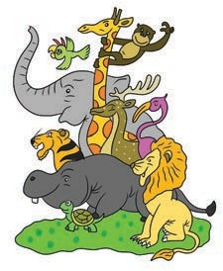

Source: [www.picturesforcoloring.com](http://www.picturesforcoloring.com/) Picture 6.4 Animals

**Speaking:** Having Mini Project

1. Work in groups. Observe how people take good care of their pets. Identify the characteristics that good pet owners have in common. Note the characteristics down and explain why your group thinks that each of those characters is essential in taking care of pets. Then, report to the class what you have noted down.

|  |  |
| --- | --- |
| **Kind of Pets:** | |
| **Characteristics of Pet Owners** | **Why Essential** |
|  |  |
|  |  |
|  |  |
|  |  |
|  |  |
|  |  |

1. Record the kinds of pets that have been reported to the class. Discuss in groups the uniqueness of each kind of pets. Do you still find similarities in the uniqueness? Do you think this happens randomly or intentionally? Who has created this all? Do you feel grateful? Share what your group has with the class.

### Writing

**Task 1:** Create your own.

Now write a factual report. Choose an animal that you like the most. You can go to the library or search in the Internet to find help. Use these subheadings when writing.

* 1. **Classification** (General information)
  2. **Description:** Appearance; Habitat; Food; Other necessary information
  3. **References:** Do not forget to acknowledge the sources you have obtained the information from.



Please write and present your text neatly and attractively.

**Task 2:** Peer Editing

Work in pairs. Exchange your writing. Check your friend’s writing. Pay attention to these points when reading it.

1. The text structure: classification (general information) and description (appearance, habitat, food, other necessary information)
2. The use of adjectives

hc.e usTe of relating verbs

* 1. Spelling
  2. Punctuation
  3. Capitalization
  4. Formatting
  5. References

1. **COMMUNICATING**

**Task 1:** Cloze description

Fill in the blanks with appropriate ***adjectives*** or ***relating verbs.***

#### Goldfish make the best imaginable pets. First of all, goldfish are extremely ____________. They don’t bark, meow, chirp, squawk, screech, or race around the house while you and your neighbors are trying to sleep. Second, goldfish

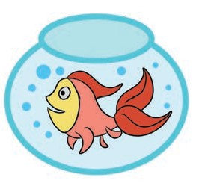

____________ very small and easy to house. They don’t take up

Source:picturesforcoloring.com

Picture 6.5 Goldfish

#### more than fifteen square inches in a ____________ house or apartment. In addition, goldfish ____________ very

____________ pets. You can buy a goldfish at your local pet store for about 50 cents, and a small bowl for it costs less than $3.00. Thus, if you want a ____________ and

____________ pet that doesn’t take up much room or cause

any trouble, visit your nearest fish store.

*Adapted from Hogue, Ann. 1996. Introduction to Academic Writing.*

**Task 2:** Writing

Rearrange the following sentences to form a good paragraph.

* 1. Zoologists, the people who study animals, classify them according to the structure of their body.
  2. This is known as classification.
  3. Animals are often grouped together according to their similarities.
  4. The simplest scientific grouping is the species, animals

that are basically alike and breed among themselves.

* 1. For example, some animals live in water, some on land; some are meat-eaters, some eat plants, and some

eat both.

**Task 3:** Speaking

Does anyone of you have an animal as a pet? Study about the characteristics of the animals like your pet in general. Share the information with your friends. Use these questions to help you.

1. What is the animal?
2. What does it look like?
3. Where does it live?
4. What does it eat?
5. How do you keep it?



Source: [www.123trf.com](http://www.123trf.com/)

**R E F L E C T I O N**

Do you know how to create a factual report? Respond to these questions to check whether you understand how to create a factual report about animals.

1. Do you use general information to introduce your topic

as a classification?

1. Do you give necessary description using subheadings (appearance, habitat, food, other information)?
2. Do you use present verbs?
3. Do you pay attention to spelling, punctuation, capitalization, and formatting?
4. Do you use references?